

**Artificial Intelligence and Data Science Department.**

OS / Even Sem 2021-22 / Experiment 2.

**___________________________________________________**

YASH SARANG.

47 / D6AD.

EXPERIMENT - 2.

Shell Script

**___________________________________________________**

**Aim:**

Learning to write and execute Shell Scripts in Unix interactive environment.

**___________________________________________________**

**Theory:**

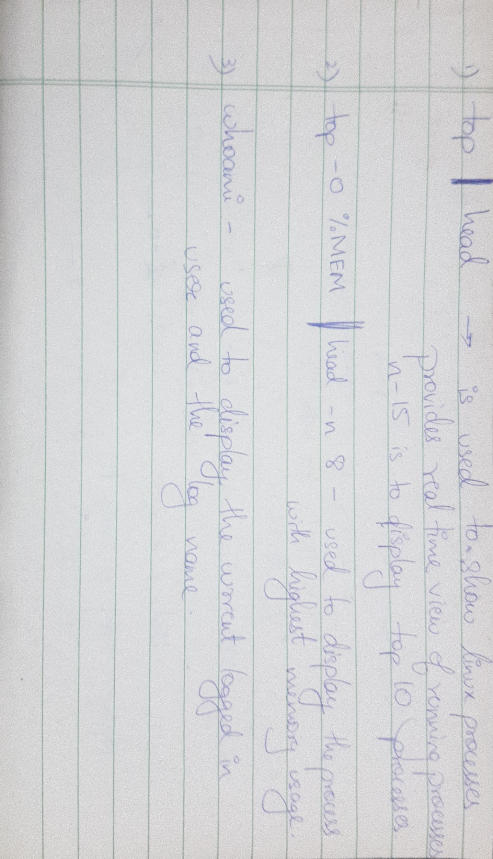

**___________________________________________________**

**Snippets:**

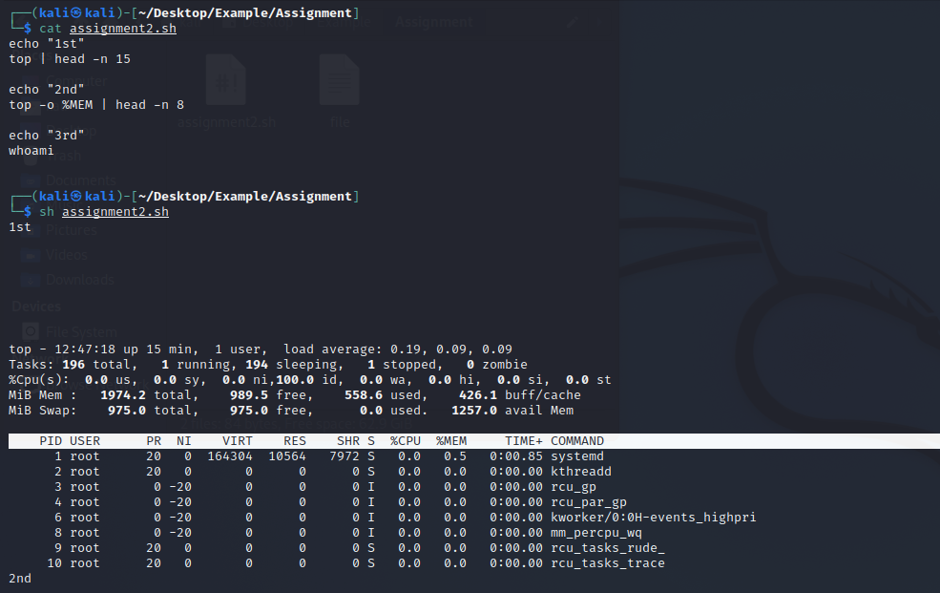

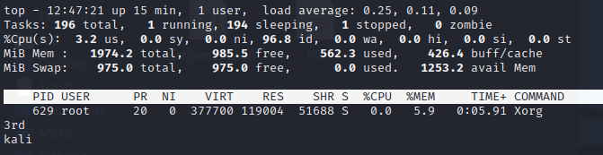

**___________________________________________________**

Conclusion:-

Thus we have learned to implement shell scripts in Unix.

**___________________________________________________**